Contents

Create an account and get an SAS user id 2

Logging into SAS studio 3

Logging out 4

Working with SAS studio 4

Making a (sub)directory for your work / project 4

Finding the path on the server to a directory (to refer/save files with a libname statement) 5

Uploading to directories and downloading files 7

Via the buttons in the upper left 7

Right-click: 7

Reading a data source (Excel, SPSS, STATA, …) into SAS 8

Permanent SAS dataset after reading it from a data source (Excel, SPSS, STATA, …) 10

Referring to directories (for data or format libraries) using library names 14

Making a new program 15

Via the folder and righ click: 15

via the right panel and right click: 15

via pressing F3 15

Running a program and seeing the output 16

Hiding and unhiding the left panel (with Server Files and Folders, Libraries etc). 16

Program, Log, Results window open next to each other 16

Creating pdf, rtf output or figures (these can be downloaded as indicated above) 17

Making comments within a program (comments are not executed) 18

# Create an account and get an SAS user id

Go to <https://welcome.oda.sas.com/> and search on that page where you can create your free SAS profile.

To this end, fill in the required data (amongst others an email address).

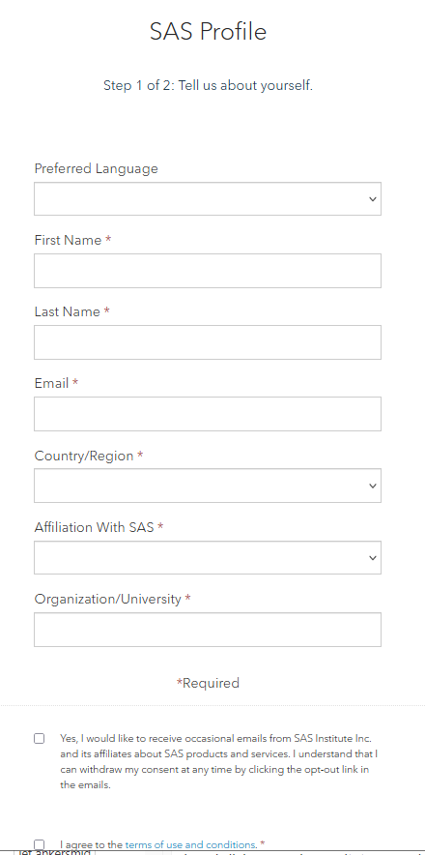

Then you receive an email to activate your account.

You can then choose a password:

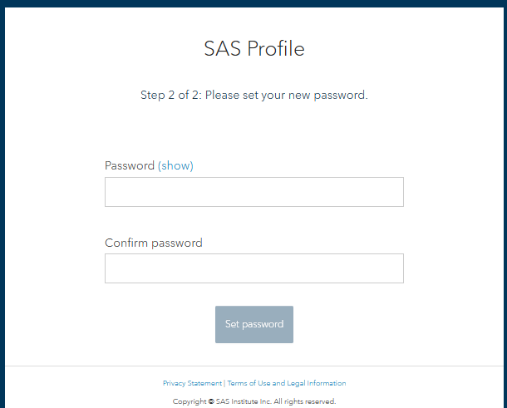

You can then login at <https://welcome.oda.sas.com/> (accept the terms of license)

but you will receive a notification that you are not registered for SAS On Demand (you only have a SAS profile).

Choose to register

Choose the region and check your email address

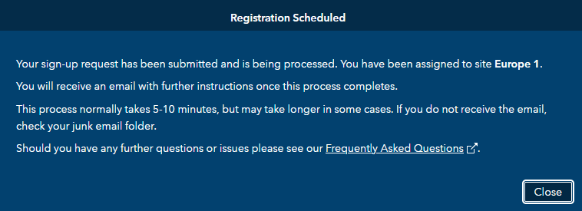

In your email you receive your SAS user id starting with a “u” and then some numbers (e.g. u12345678).

You can use SAS on Demand using either this user id and password, or using your emailaddress and password.

# Logging into SAS studio

Log in at <https://welcome.oda.sas.com/>

with email-adress or sas user id (e.g., [name@provider.country](mailto:name@provider.country) or u12345678).

Then launch SAS Studio.

You will the following:

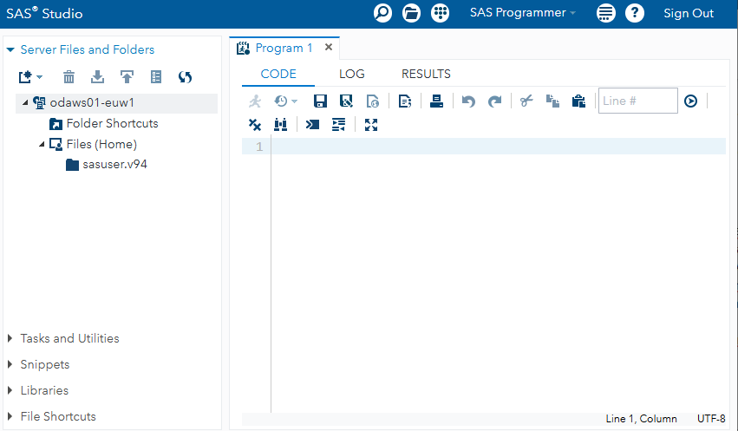

You can see your username in SAS studio in the when you point the mouse on the “Sign Out”:

12345678

or

on the bottom right in SAS studio

# Logging out

You first log out of SAS studio (top right) and then log out from your SAS profile (top right where your name is stated, take the pull down menu)

# Working with SAS studio

Basically you are working on a UNIX server where you run SAS. You have your own home directory ( /home/u<userid>) where you can make directories, store (and upload and download) dataset, make and run sas programs, and save (and download) output files with results, figures, tables etc.

## Making a (sub)directory for your work / project

In the right panel click your main folder (“Files (Home)”) you can create a new folder

|  |  |
| --- | --- |
|  |  |

and give it a name

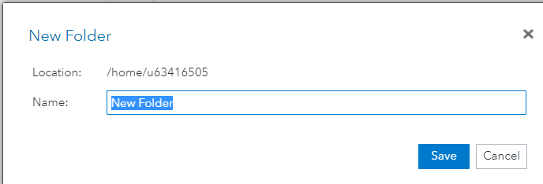

## Finding the path on the server to a directory (to refer/save files with a libname statement)

Right-clicking on the file or directory shows you the filepath

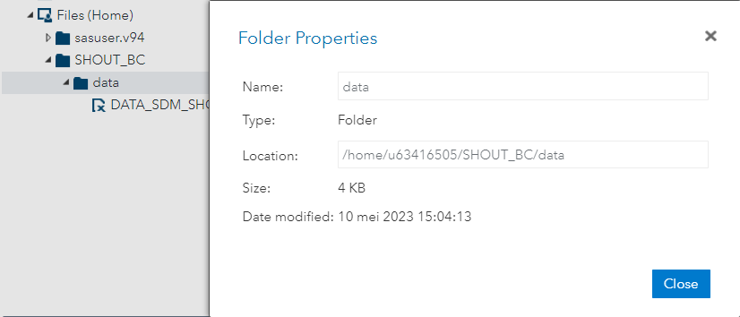

So you can make statements like

libname dir “/home/us63416505/SHOUT_BC/analysis”;

and then use relative file paths like

libname data “../data”;

when your current directory is dir and you want to refer to the directory “/home/us63416505/SHOUT_BC/data”

## Uploading to directories and downloading files

**Select** the *folder* to upload a file to

or   
**select** the *file* to download.

There are at least two ways:

### Via the buttons in the upper left

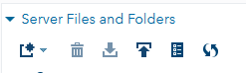

### Right-click:

|  |  |
| --- | --- |
| After selecting a directory to upload: | After selecting a file to download: |

## Reading a data source (Excel, SPSS, STATA, …) into SAS

After uploading the data file, select it an right click:

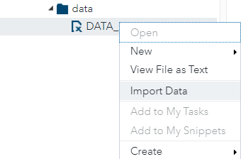

In the right panel, a program to read the data will be generated (on the bottom):

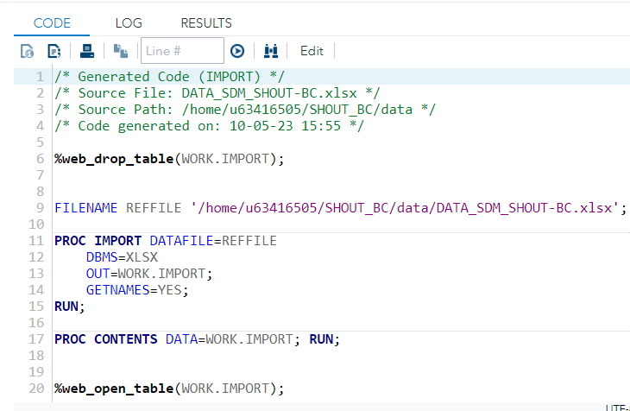

In the top right window, some meta information on the program will be given, e.g. options used.

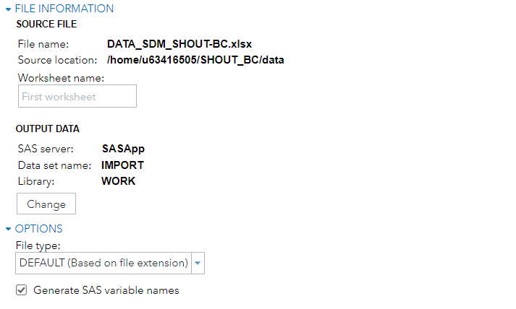

The program still has to be run (select and then F3 or the run button):

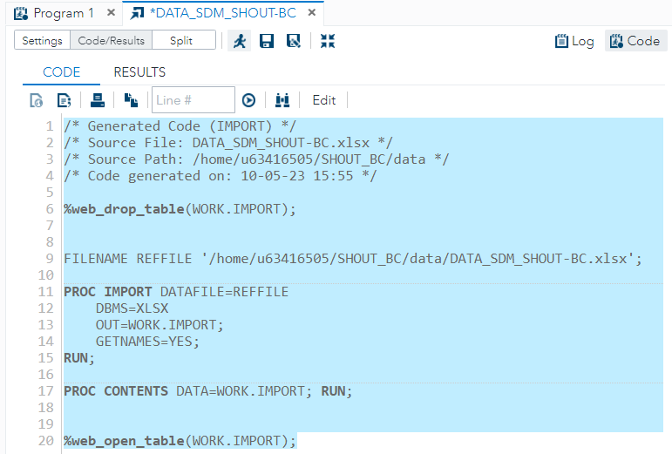

The data is read now but will only be in a temporary directory ‘work’ (and will be lost if you log-out).

This can be seen in the left panel after selecting “Libraries”:

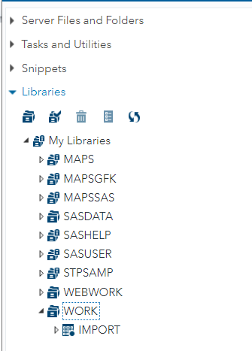

You can double click (here “IMPORT”) to see its contents

Note that also variable information (after selecting it) can be seen (left down panel):

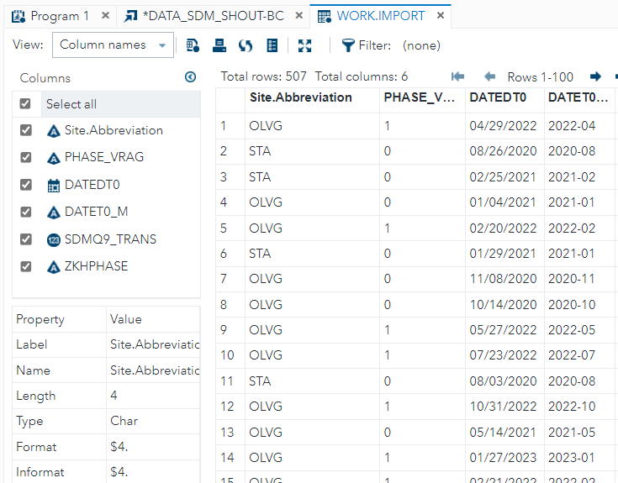

## Permanent SAS dataset after reading it from a data source (Excel, SPSS, STATA, …)

To avoid reading the data from source every time one logs in, we can make it into a permanent dataset.

For this we need

* a folder (here we use the “data” folder we created as above);
* making some changes to the import program created above

We go to the import program made above and click the “CODE’ panel and then click “Edit”:

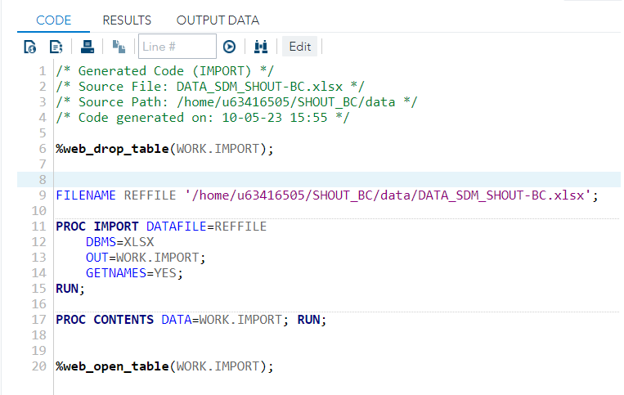

We change it to (highlight):

****

LIBNAME data '/home/u63416505/SHOUT_BC/data'; * reference to a directory;

FILENAME REFFILE '/home/u63416505/SHOUT_BC/data/DATA_SDM_SHOUT-BC.xlsx';

PROC IMPORT DATAFILE=REFFILE

DBMS=XLSX

OUT=data.shout_bc; *choice of sas permanent data file;

GETNAMES=YES;

RUN;

******

Note that libname uses an absolute path (/home/u63416505/ is the home directory).

Note that the ‘libname’ data is used in the OUT statement and we made a choice for the name of the dataset (here “shout_bc”).

We run the program by selecting the programming lines and then press F3 or use the ‘run’ button .

In the left panel -> Libraries , we can find our dataset back

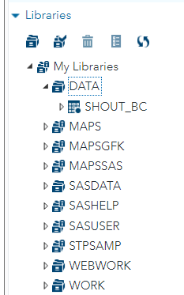

For completeness, we save the import program (although we would not need to import the data again, as it is permanent now). That can be useful when another source file is uploaded and we want to overwrite the current permanent dataset.

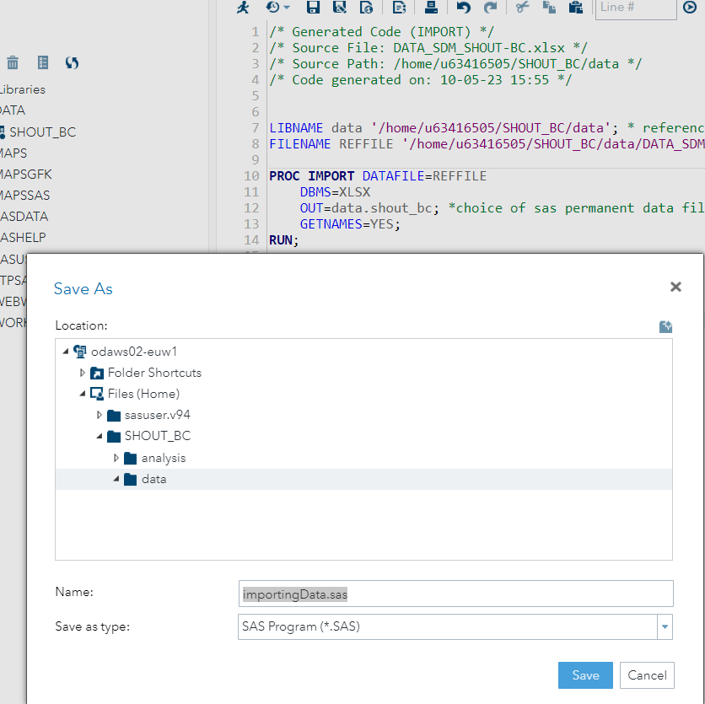

In the left panel-> Server and Folders, we can find now our import program back:

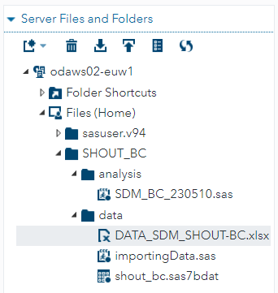

## Referring to directories (for data or format libraries) using library names

Library names can be assigned using the most left symbol  (the file cabinet):

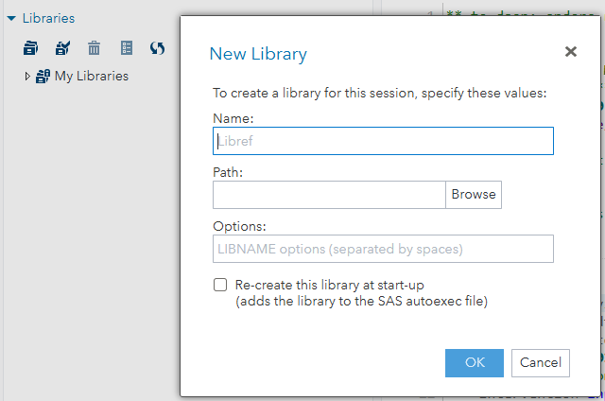

## Making a new program

First select the folder where you want the program in (here “analysis”) in the left panel -> Servers and Folders:

### Via the folder and righ click:

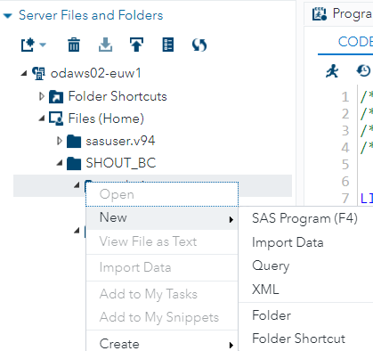

### via the right panel and right click:

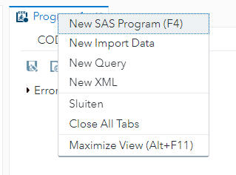

### via pressing F3

## Running a program and seeing the output

We run the program by selecting the programming lines and then press F3 or use the ‘run’ button .

## Hiding and unhiding the left panel (with Server Files and Folders, Libraries etc).

Use the symbol:



in the righ panel:

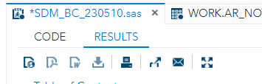

## Program, Log, Results window open next to each other

The several windows can be viewed together by dragging them and releasing them.

E.G. left click on the log panel on top:

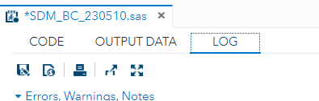

Then drag it (you see the red marking):

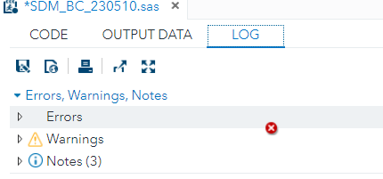

Release when you see the green marking



For example, you can thus create a left-up, left-bottom and right-panel (e.g. a CODE window left up (with an extra tabl for “OUTPUT DATA”), a LOG window right, and a results on the bottom).

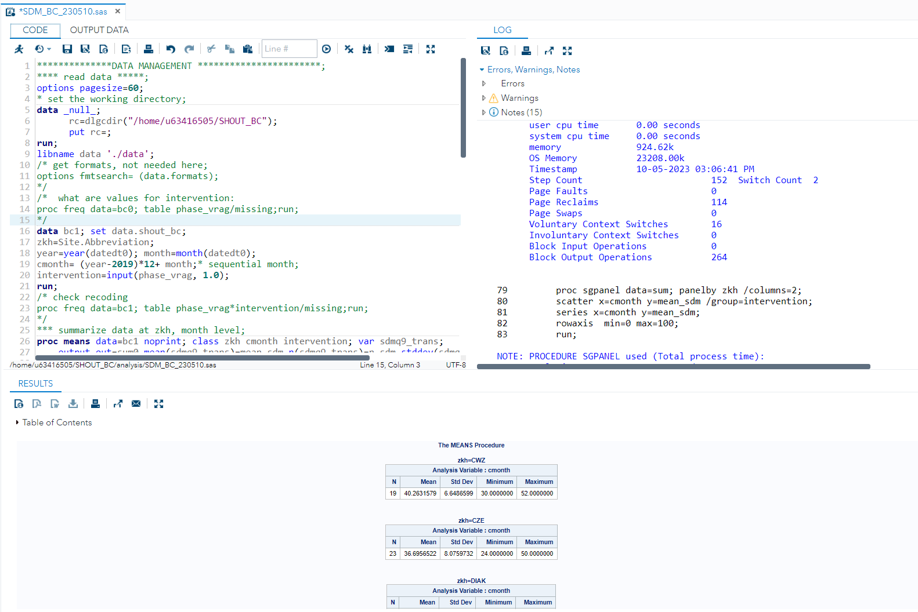

See also:

https://communities.sas.com/t5/SAS-Software-for-Learning/Viewing-the-editor-log-and-ouput-windows-simultaneously-on-SAS/td-p/846626

## Creating pdf, rtf output or figures (these can be downloaded as indicated above)

* saving as an rtf file;

ods rtf file== '/home/u63416505/SHOUT_BC/results/output.rtf';

…(procedures to be output)…

ods rtf close;

* saving it as a jpg file;

ODS GRAPHICS / RESET IMAGENAME = 'Final' IMAGEFMT =JPEG

HEIGHT = 2in WIDTH = 3in;

ODS LISTING GPATH = '/home/u63416505/SHOUT_BC/results' ;

*

…(code for the figure to be output)..

ODS GRAPHICS /RESET;

* saving it as a pdf file;

ods pdf file="/home/u63416505/SHOUT_BC/results/sgpanel.pdf";

… (code to be output) …

ods pdf close;

see also the internet, e.g., <https://www.mwsug.org/proceedings/2010/how/MWSUG-2010-51.pdf>

## Making comments within a program (comments are not executed)

Text between “*” and “;” (suitable for commenting our one line) or between “/*” and “*/” (suitable for commenting out several lines).